IBM INTERNAL USE ONLY

Setup Guide of a BlueMix Demonstration for a Chief Human Resources Officer (CHRO)

The source code for the demo is available via git from a JazzHub repository. The JazzHub project is located at https://hub.jazz.net/project/osipov/node-linkedin-js-v9/overview

Ensure that you have a Jazz.net account which you can obtain by registering here https://hub.jazz.net/register To obtain access to the JazzHub project for the demo, email Carl Osipov ( osipov@us.ibm.com ) and cc ET Dev Advocates mailing list.

To checkout the code run the following command

git clone https://hub.jazz.net/git/osipov/node-linkedin-js-v9

which should download roughly 19MB worth of demo code and assets into a node-linkedin-js-v9 directory.

Modify the manifest.yml file in the node-linkedin-js-v9 directory to replace the string node-linkedin-js-v9 with your desired application name and hostname. Note that BlueMix will attempt to register a URL with a suffix ng.bluemix.net for you (e.g. node-linkedin-js-v9.ng.bluemix.net) which means that you must ensure that your hostname is unique.

This document will use the <HOSTNAME> string in place of your hostname AND application name in the examples. You will need to replace the string when following the instructions.

Since your demo is going to be using LinkedIn API, your application will have be whitelisted with LinkedIn. To do that, send an email to Carl Osipov ( osipov@us.ibm.com ) and cc ET Dev Advocates mailing list. The email should specify your <HOSTNAME>.ng.bluemix.net and ask for it to be whitelisted for the CHRO demo.

Open the following link from your browser, login using your IBM ID and click on “Create a new client”. https://idaas.ng.bluemix.net/idaas/developer/manageoauthclients.jsp

Leave client identifier and client secret as <auto> and type in
LinkedInOutreach for the Display Name
https:// <HOSTNAME>.ng.bluemix.net / for the Redirect URI

A sample screenshot is shown below.
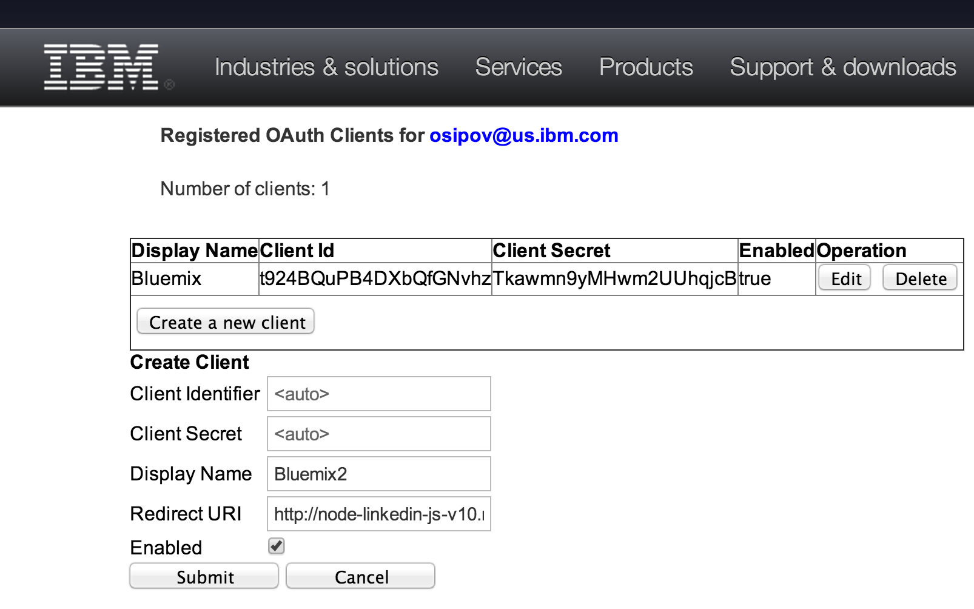

Check off the “Enabled” box. Click Submit. Note the generated values for client ID and secret as they will be referenced as <SSO_CLIENT_ID> and <SSO_CLIENT_SECRET> at later time.

The demo code saves LinkedIn profiles into a Cloudant database. You can choose to to create your own Cloudant database for the profiles or rely on a shared database for testing. It is strongly recommended that you create your own Cloudant database for demos because doing so will ensure that you will not encounter unexpected content from the database during the demos.

If you choose to create your own Cloudant database, you will need to perform the following steps to use it in the demo.

Ensure that you have a registered account on cloudant.com and note your Cloudant URL which is usually your username followed by cloudant.com. Replace <CLOUDANT_URL> in this documentation with this value.

Login to cloudant.com and make sure you are using the new dashboard.

From the databases menu, click on Add New Database and specify a name. When following this documentation replace <CLOUDANT_DATABASE> with the name you specified.

Click on the little lock icon to the right of the database name to set permissions.

Check off Reader rights for “Everybody Else”

Click on Generate API Key and make a note of the key and password values. When following this documentation, replace <CLOUDANT_USERNAME> and <CLOUDANT_PASSWORD> with these values.

Check off Writer rights for <CLOUDANT_USERNAME>

Go back to the databases menu and click on your database (example on screenshot below)
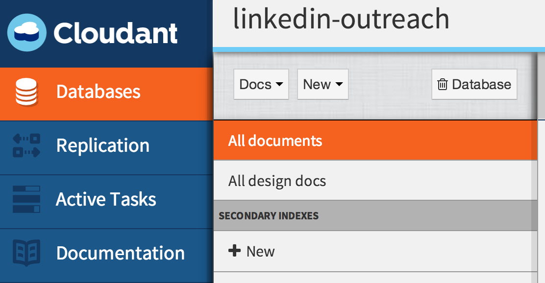

Click on New dropdown and choose Document. In the opened editor, replace the content with the content of the _design.json file located in your node-linkedin-js-v9 directory. Save the changes.

Note that your database screen should now show new secondary indexes: profiles/profile and profiles/csv

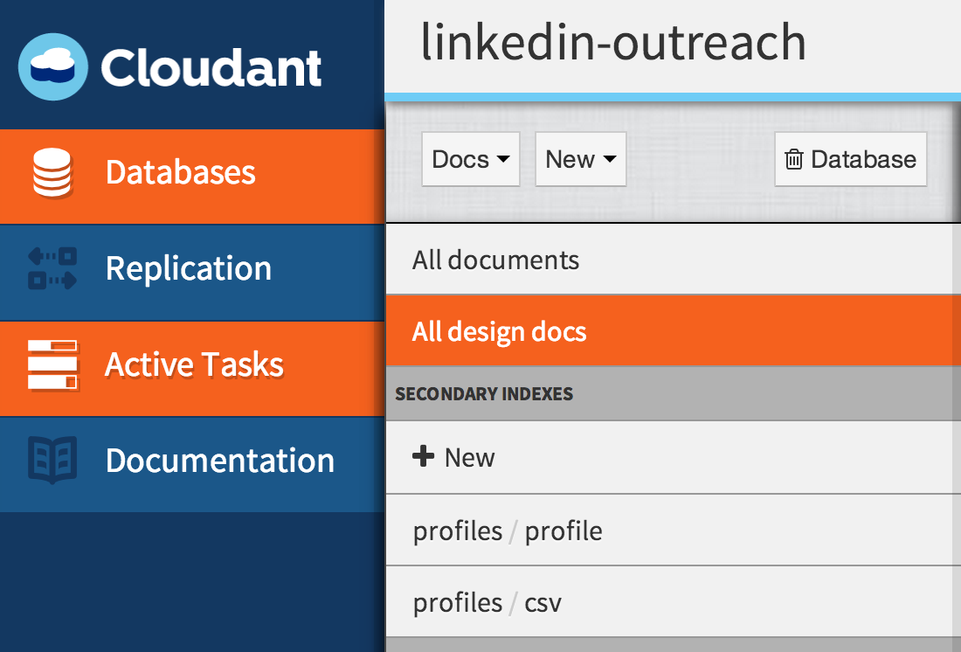

To create your BlueMix application

Login to the BlueMix portal using your IBM ID at www.bluemix.net

From the Bluemix catalog, click on Node.js runtime and click Create App

Specify the app and host names using the <HOSTNAME> value for both (see example below)

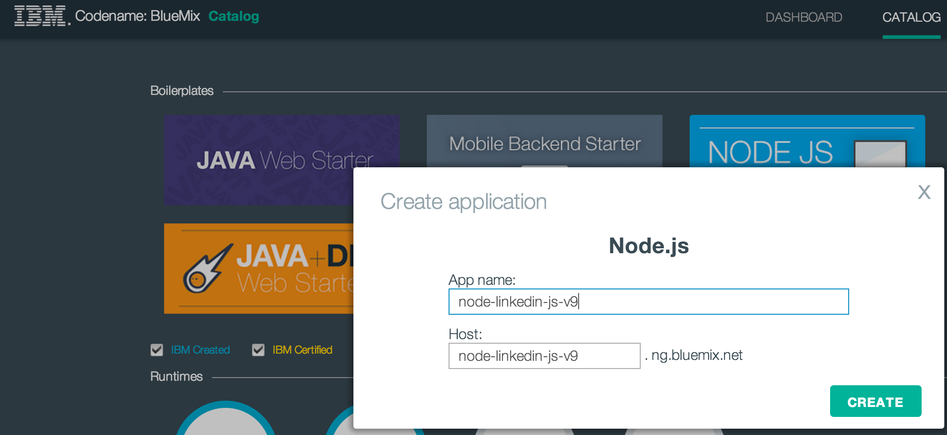

Navigate to the Dashboard view and click on your application named <HOSTNAME>

Click on Add new service

If you chose to use your own Cloudant database

Select Cloudant in the service catalog, click on Add to application and fill in values using <CLOUDANT_URL> / <CLOUDANT_DATABASE>
(e.g. https://osipov.cloudant.com/crud ) as well as <CLOUDANT_USERNAME> and <CLOUDANT_PASSWORD>

Click on Create.

Go back to the application to add another service

Click on SSO, Add to application. Choose your application name and click Create.

Navigate back to the Dashboard. Click on your application and on the left sidebar menu choose runtime.

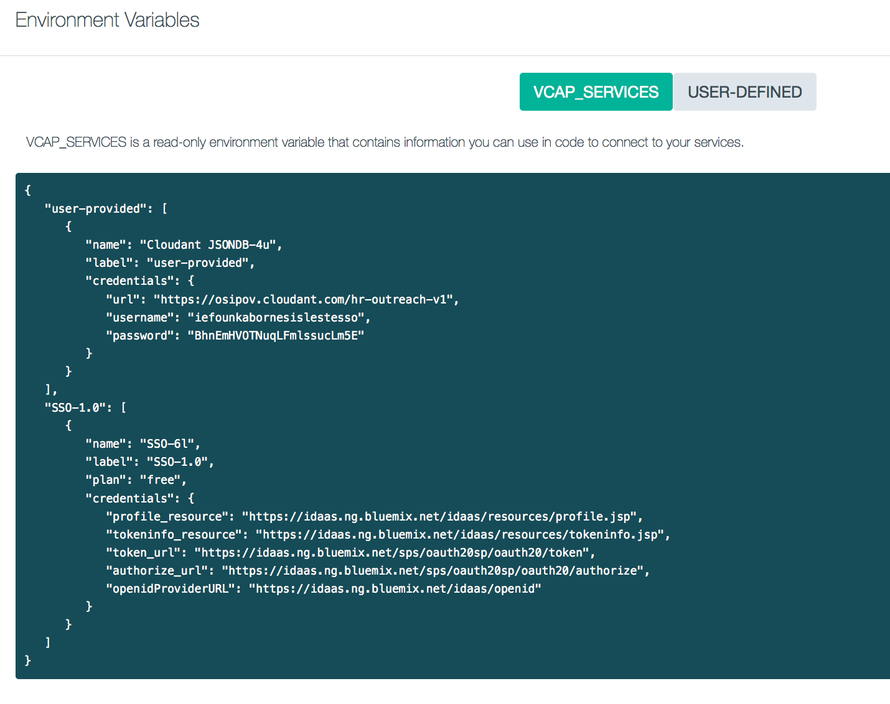
Scroll all the way to the bottom of the screen and confirm the presence of VCAP_SERVICES that should look similar to the screenshot below.

Note that if you chose not to use your own Cloudant database, the corresponding section of the VCAP_SERVICES will be missing.

Click on the USER-DEFINED button which is next to VCAP_SERVICES.
Using the Add button, create two variables named SSO_CLIENT_ID and SSO_CLIENT_SECRET with values <SSO_CLIENT_ID> and <SSO_CLIENT_SECRET> respectively. An example is shown on the screenshot below

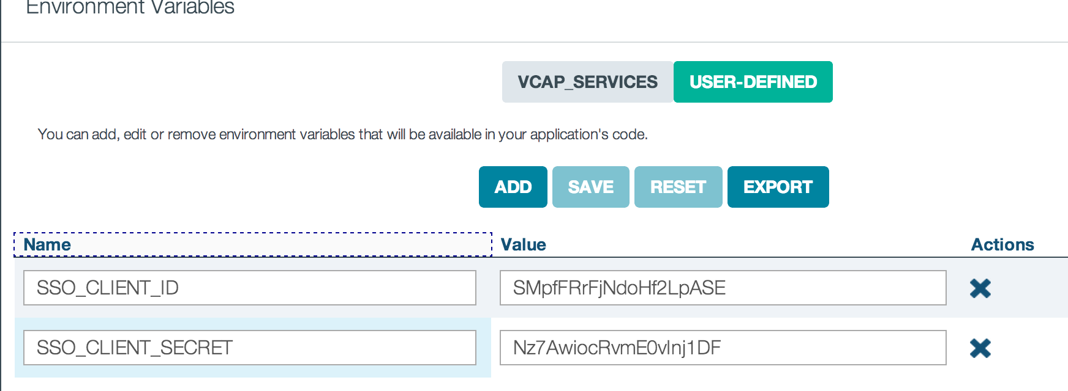

Save the changes.

Return back to the console (terminal) and change your directory to node-linkedin-js-v9

To deploy the code to BlueMix, execute the following command from the terminal

cf push -c 'node main.js'

The code should successfully deploy and the application should start.

Validate that the application is working by browsing to http://<HOSTNAME>.ng.bluemix.net You should see a screen similar to the one on the screenshot below. Other application URLs include
http://<HOSTNAME>.ng.bluemix.net/profiles
http://<HOSTNAME>.ng.bluemix.net /admin
http://<HOSTNAME>.ng.bluemix.net /dashboard
http://<HOSTNAME>.ng.bluemix.net/dashboard#a

